**SECTION-2**

**Submitted by: Sanchita Nagulwar**

**(CSS assignments) Steps to follow:**

1. **Create a new branch ‘css-assignments’**.

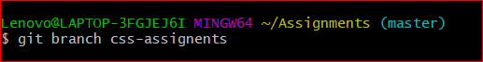

1. **Switch to ‘css-assignments’ branch.**

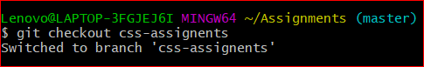

1. **Copy all CSS assignments inside ‘Assignments’ folder.**

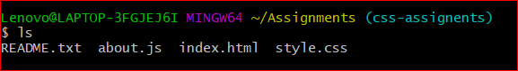

1. **Commit CSS assignments into ‘css-assignments’ branch.**

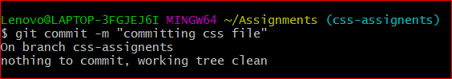

1. **Make minor changes into README.txt file on line 1 belonging to ‘css-assignments’ branch.**

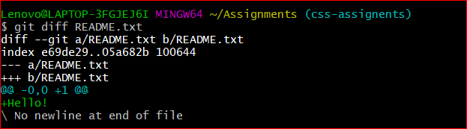

1. **Commit those changed files.**

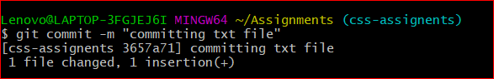

1. **Switch to master branch**.

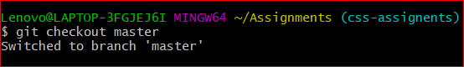

1. **Make minor changes into README.txt file on line 3 & commit those changes into master.**

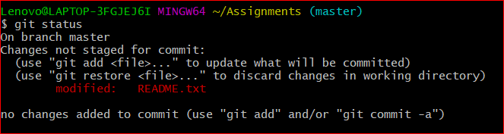

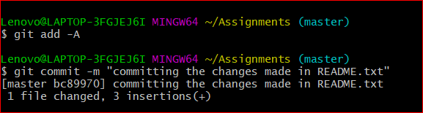

1. **Again switch to ‘css-assignments’ branch.**

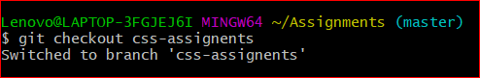

1. **Make minor changes into few files belonging to ‘css-assignments’ branch.**

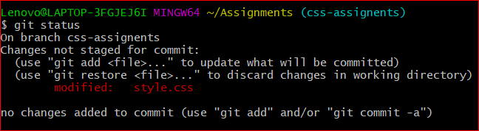

1. **Commit those changes**

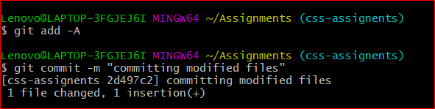

1. **Switch to master.**

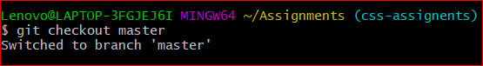

1. **Merge ‘css-assignments’ branch into master. Confirm all css assignments are shown in master.**

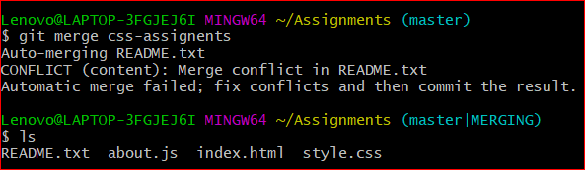

1. **Finally delete the ‘css-assignments’ branch.**

